Optimized Missionary Allocation: Linear Programming for the Glory of God

Introduction
"Go therefore and make disciples of all nations, baptizing them in the name of the Father and of the Son and of the Holy Spirit"
In Matthew 28:19 (ESV), Jesus commands us to go out in the world, and make disciples of all nations. It is my conviction that we ought to use any resources and abilities that God has given us to achieve that end. As such, for any task that requires resources, quantitative methods can be used to determine how to “best” go about using these resources. Thus, I have employed a linear programming model to attempt to describe the “optimal” placement of missionaries that effectively covers “all nations” while also minimizing the amount to be sent. While the results of this project may be a “toy”, limited in scope and reductionistic in nature, I do hope those who do consider where to be sent prayerfully consider this. Numerous factors contribute to make this a deeply flawed model of the real world – such as outdated sources, missing data points, and unrealistic assumptions; What this does do though is serve as a useful heuristic to evaluate where the most need is in India and how it may be best addressed.

Data Collection
To fuel the linear programming machine, we needed data on unreached people groups to find where the most desperate need is. As such, a natural choice was from Joshua Project in their vast amount of specialized data on different people groups (this is an example).
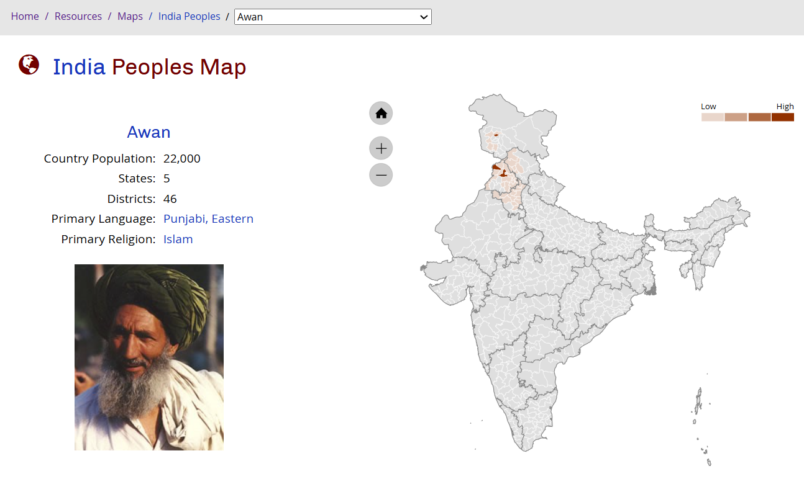
Figure 1
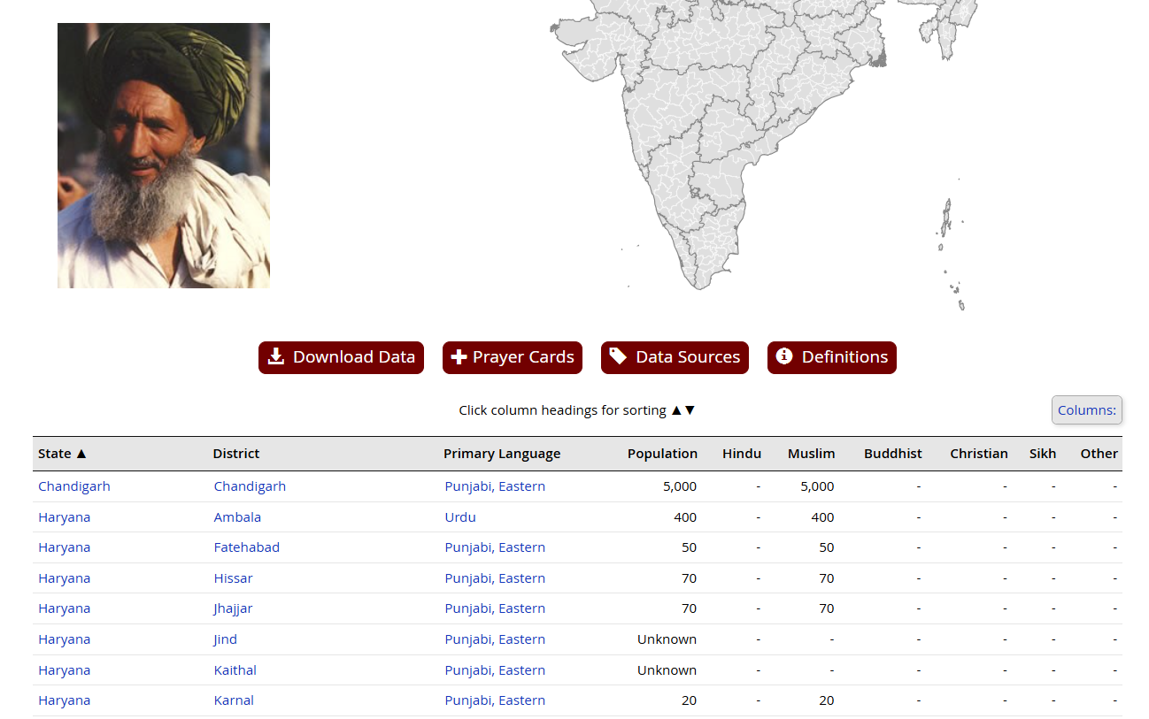
Figure 2
Unfortunately, this data was not easy to collect in mass, it was confirmed there was no API for the dataset, so I was left to scrape the website. I did this by collecting the links of the html dropdown at the top to cycle through and collect the data as seen in Figure 2. See the Data Scraping Folder for more details.

Linear Programming
With the data gathered from above, I then set up a linear programming model to calculate optimal missionary allocation. Underlying the model are the following assumptions:
- A missionary’s impact is spread evenly throughout a district
  - That is, each people group is impacted proportionately to their general proportion to the district’s population
- A missionary impacts 10,000 people within a lifetime
- Optimally, at least 10% of each people group must already be Christian or impacted by missionaries
- There are an integer number of missionaries
So, our LP is a minimization problem, minimizing the total amount of missionaries $x_{i}$ sent to each district $i$
Minimize $Z=\sum_{i=0}^{n}{x_{i}}$
Subject to the constraints of
$$C_{j}+\sum_{i=0}^{n}{10000c_{ij}x_{i}}>\frac{p_{j}}{10}$$
$x_{i}≥0$, integer
Where $c_{ij}$ is the reach factor for each district $i$ and people group $j$, $p_{j}$ is the people group’s population, $C_{j}$ is the Christian population of the people group $j$.
Also $c_{ij}=\frac{p_{ij}}{p_{i}}$ where $p_{ij}$ is the population of a people group $j$ in district $i$ and $p_{i}$ is the total population of district $i$.
One could suggest from here we do a normal LP and just round any non-integer up, but it was easier to just make it a mixed integer programming problem and so I used Google OR-tools to run the model. The inputs/outputs and code to generate it are in the Linear Programming folder. In the end, we were left with 14899 missionaries to send to India.

Map Visualization
To complement the outputs of this linear programming model, I decided to search out a way to display all of the information on an interactive map (see MissionaryMap.html). There were many maps out there but I ultimately settled on the same AmCharts map of India that was used by Joshua project to create their visualizations. This was mostly due to the ability to link up the internal ID of each district and map it to my own outputs as opposed to manually going in myself. As a result of this, (Joshua project does this too) there were missing IDs for a few of the described districts which I accounted for by adding the scrollable table at the bottom of the html webpage. If I continue this project for a potential Honor Thesis, then I would spend more time perfecting each data point, but it is sufficient for now.

